Nmap is best.

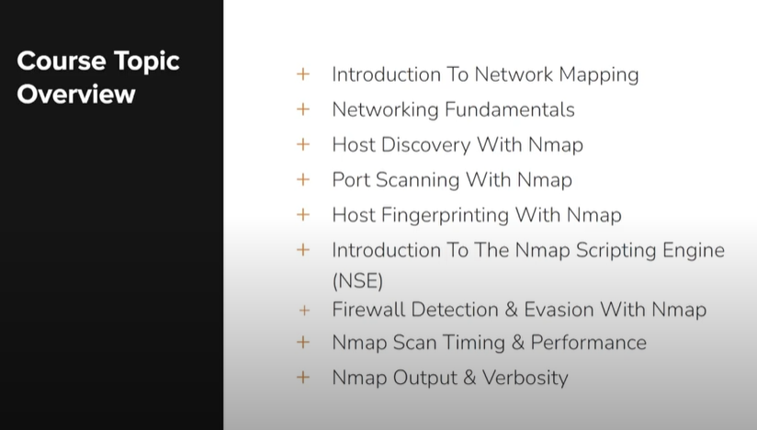

Network = iso +udp + tcp+network layer(ip works) +transport layer(tcp//udp)
Identify host/discovery = active ips
Identify Os = running on active system --NSE
Port open =
Services on the port =

Must know the common tcp/udp port:
Ssh=22 (tcp)
80=http (tcp)
443=https (tcp)

Typically the smb port is open on the window system.
